*Florida International University*

*School of Computing and Information Sciences*

Software Engineering Focus

Feature Document

User Story ID <0003>

**Name:** Jose/Parker

**Team Member(s): Jose, Parker**

**Project: Learning with Augmented Reality 4.0**

**Product Owner(s)**: Ms. Vassigh

**Mentor(s)**: -

**Instructor**: Masoud Sadjadi

**User Story Name:**

This User Story is primarily to denote the integration of the Oculus Rift development libraries into the environment and add the capability of viewing as a user. This specific feature document is for viewing the scene, not moving throughout the scene.

* Description: **As a** User **I would like** to be able to utilize the Oculus Rift and look around the scene in Unity **so that** I can visualize SIPA in Virtual Reality.

Acceptance Criteria

* No errors when attempting to compile our current product in Unity.
* Ability to view scene in Oculus

**Use Case**

* Name:
* Actor:
* Preconditions:
* Description <Flow of events>:

**Use Case Diagram <**you can use draw.io**>**

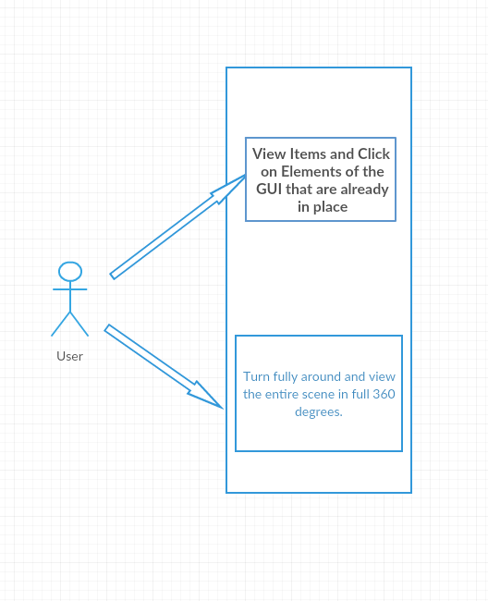

**Sequence Diagram**

N/A

**Class Diagram**

N/A

**Not sure how either of these documents would really be created for a feature like this. If there are any suggestions, we’ll definitely create them.**

**Unit Test**

* Test case ID: <00002>
* Description/Summary of Test:
* Pre-condition:
* Expected Results:
* Actual Result:
* Status (Fail/Pass):

**Integration Test**

This has not been fully integrated as of yet.

**Visual User Guide** <like one or two screenshots of the feature. For the hardware project, a photo of device is required>

